***SOFTWARE TESTING***

Requesting all participants to download below corresponding software versions before the start of the class.

1. Eclipse latest version
2. JDK 17
3. Selenium jar file
4. Chromedriver.exe
5. TestNG

**Steps to install Eclipse :**

Step 1 : Navigate to <https://www.eclipse.org/downloads/packages/release/2024-06/r>

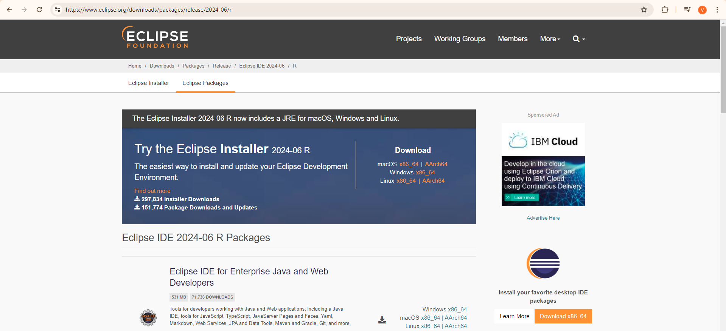

Step 2 : Search for [Eclipse IDE for Enterprise Java and Web Developers](https://www.eclipse.org/downloads/packages/release/2024-06/r/eclipse-ide-enterprise-java-and-web-developers)

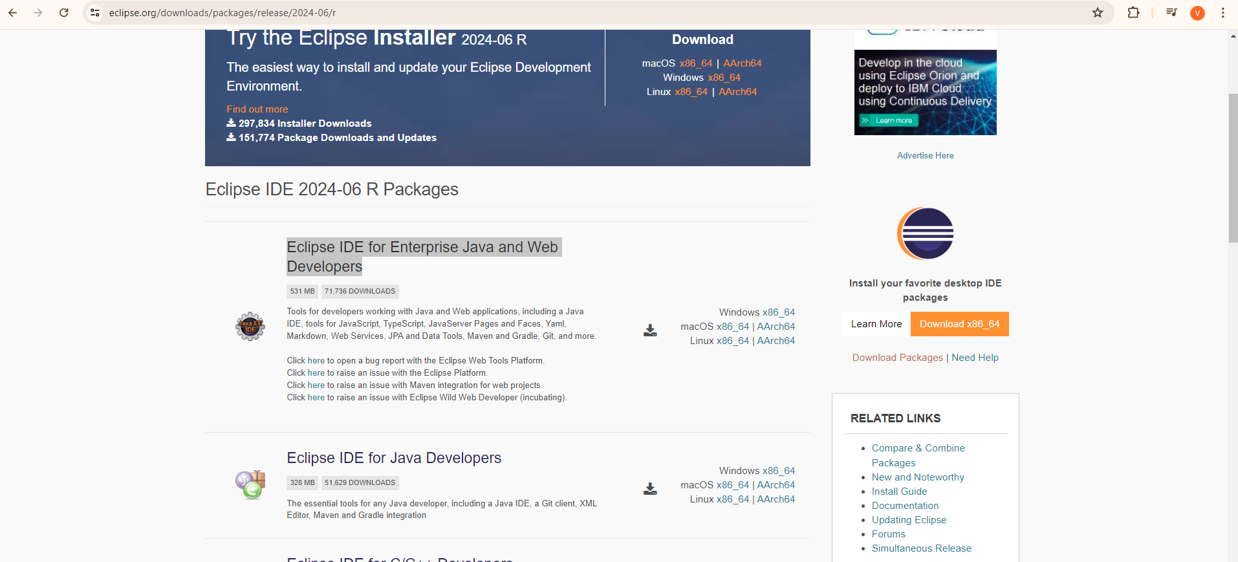

Step 3 : Click on Windows *86_64

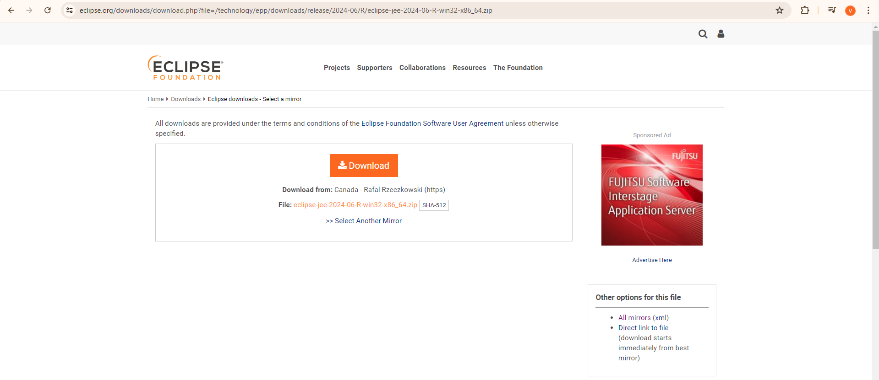

Step 4 : Click on download and set up the eclipse.

**Steps to install JDK 17 :**

Step 1 : Navigate to <https://www.oracle.com/java/technologies/javase/jdk17-archive-downloads.html>

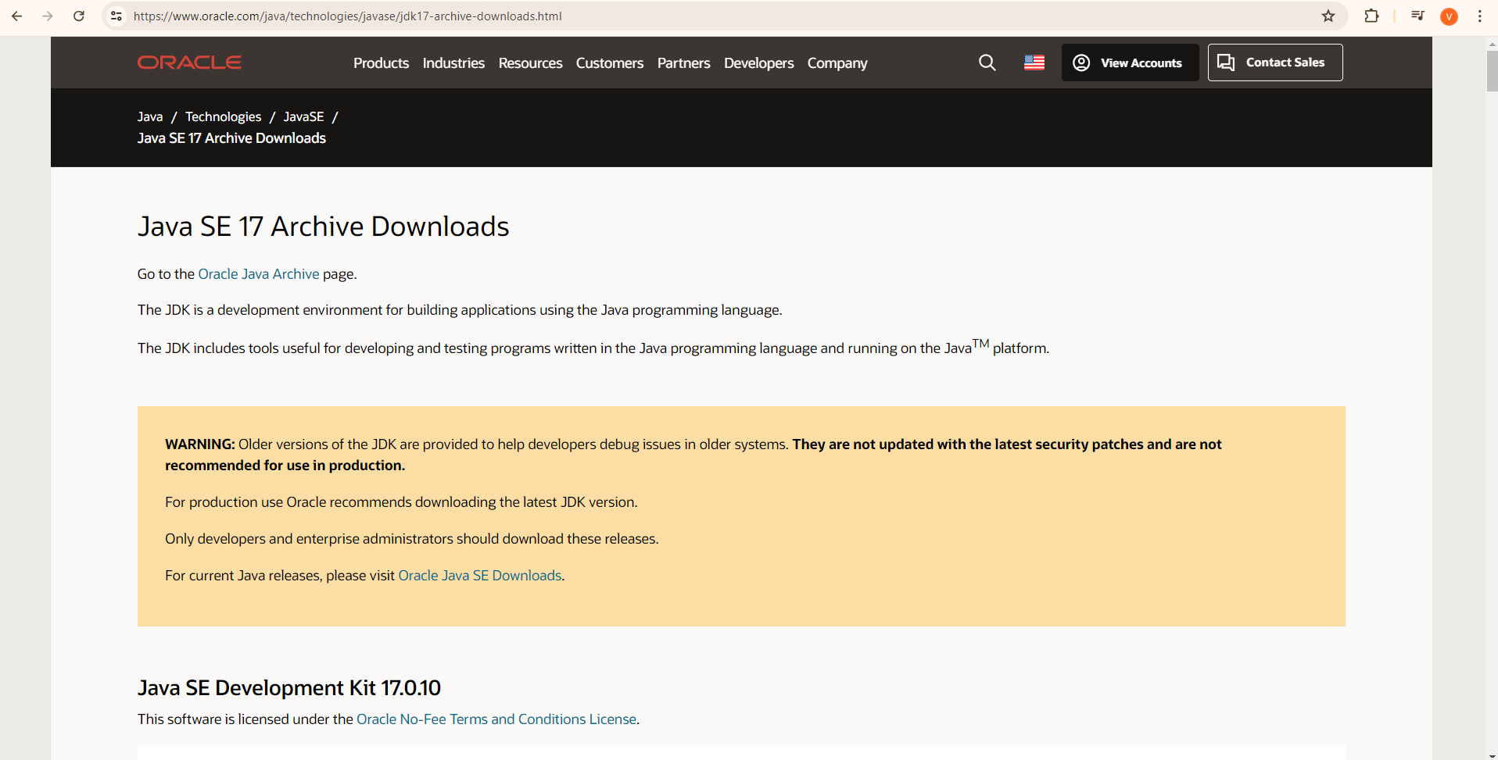

Step 2 : Scroll down until Windows x64 Installer

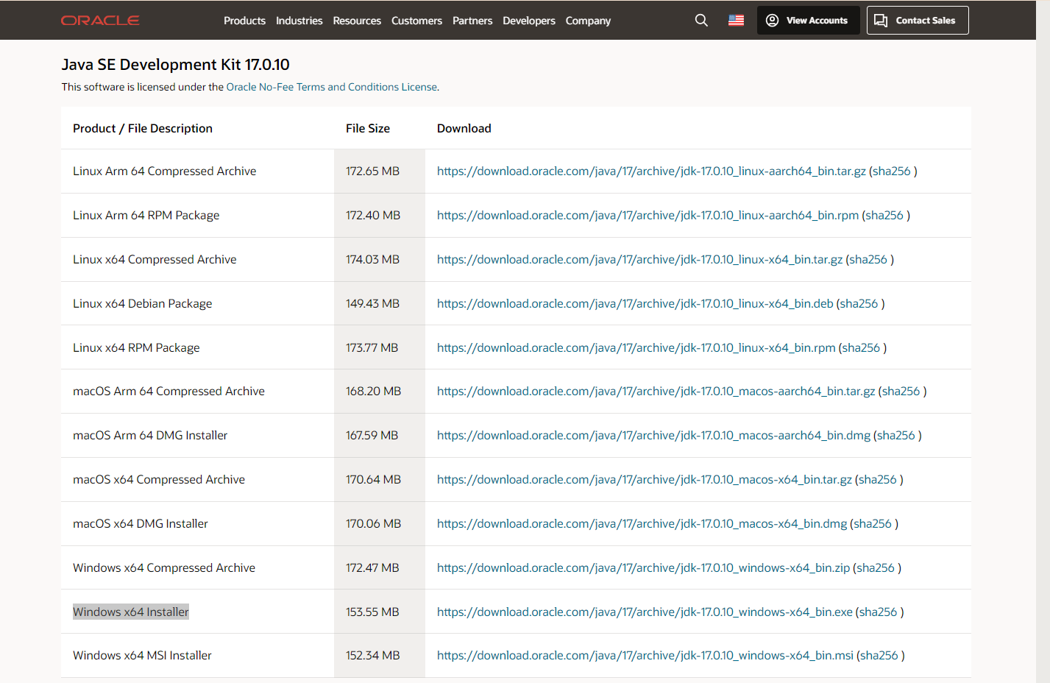

Step 3 : Click on the link to download jdk

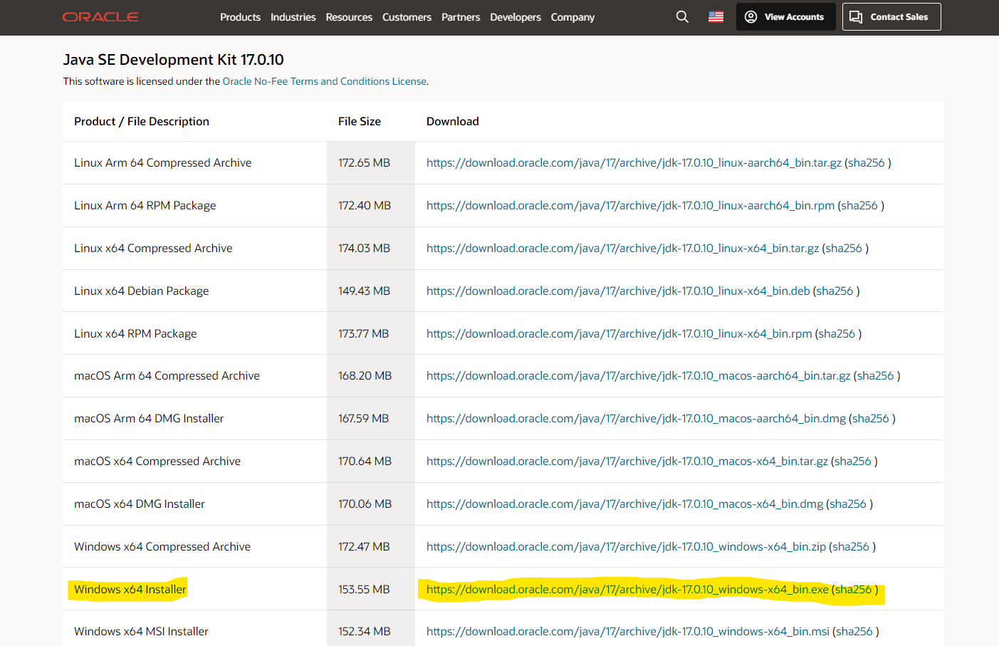

**Steps to install Selenium jar file :**

Step 1 : Navigate to <https://www.selenium.dev/>

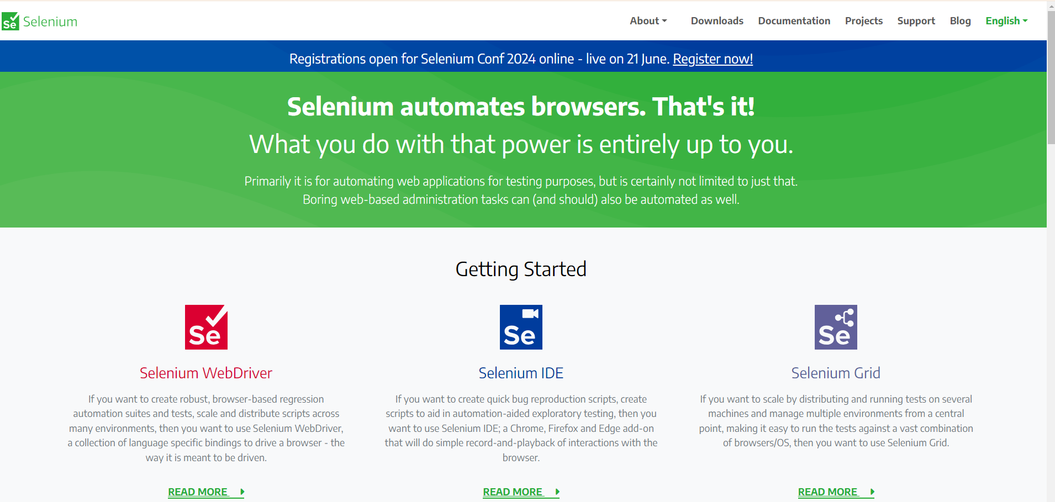

Step 2 : Click on Downloads

Step 3 : Scroll down until Selenium Server (Grid)

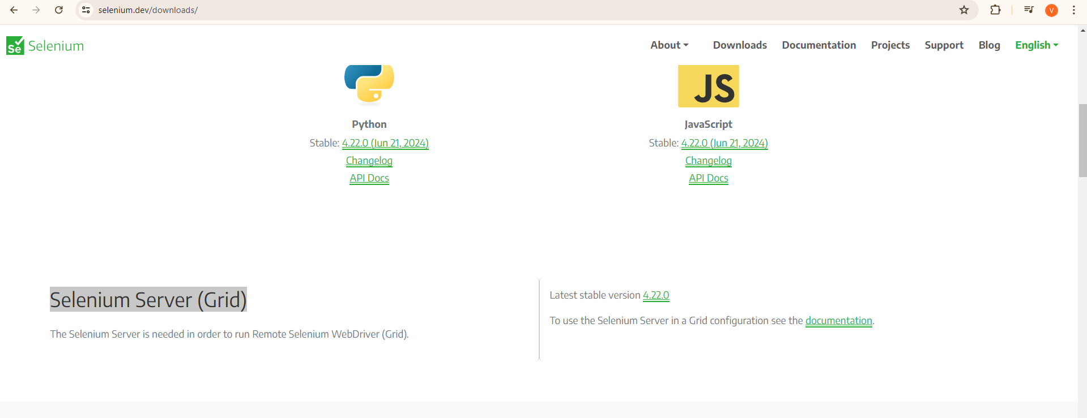

Step 4 : Click on latest stable version and download

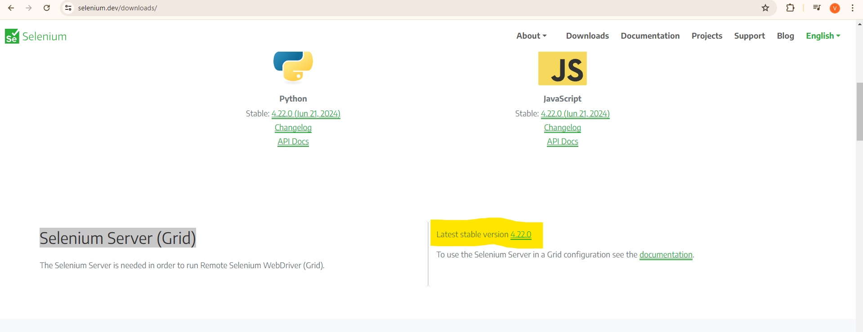

**Steps to install Chromedriver :**

Step 1 : Navigate to <https://www.selenium.dev/> 

Step 2 : Click on Downloads

## Step 3 : Scroll down until Platforms Supported by Selenium

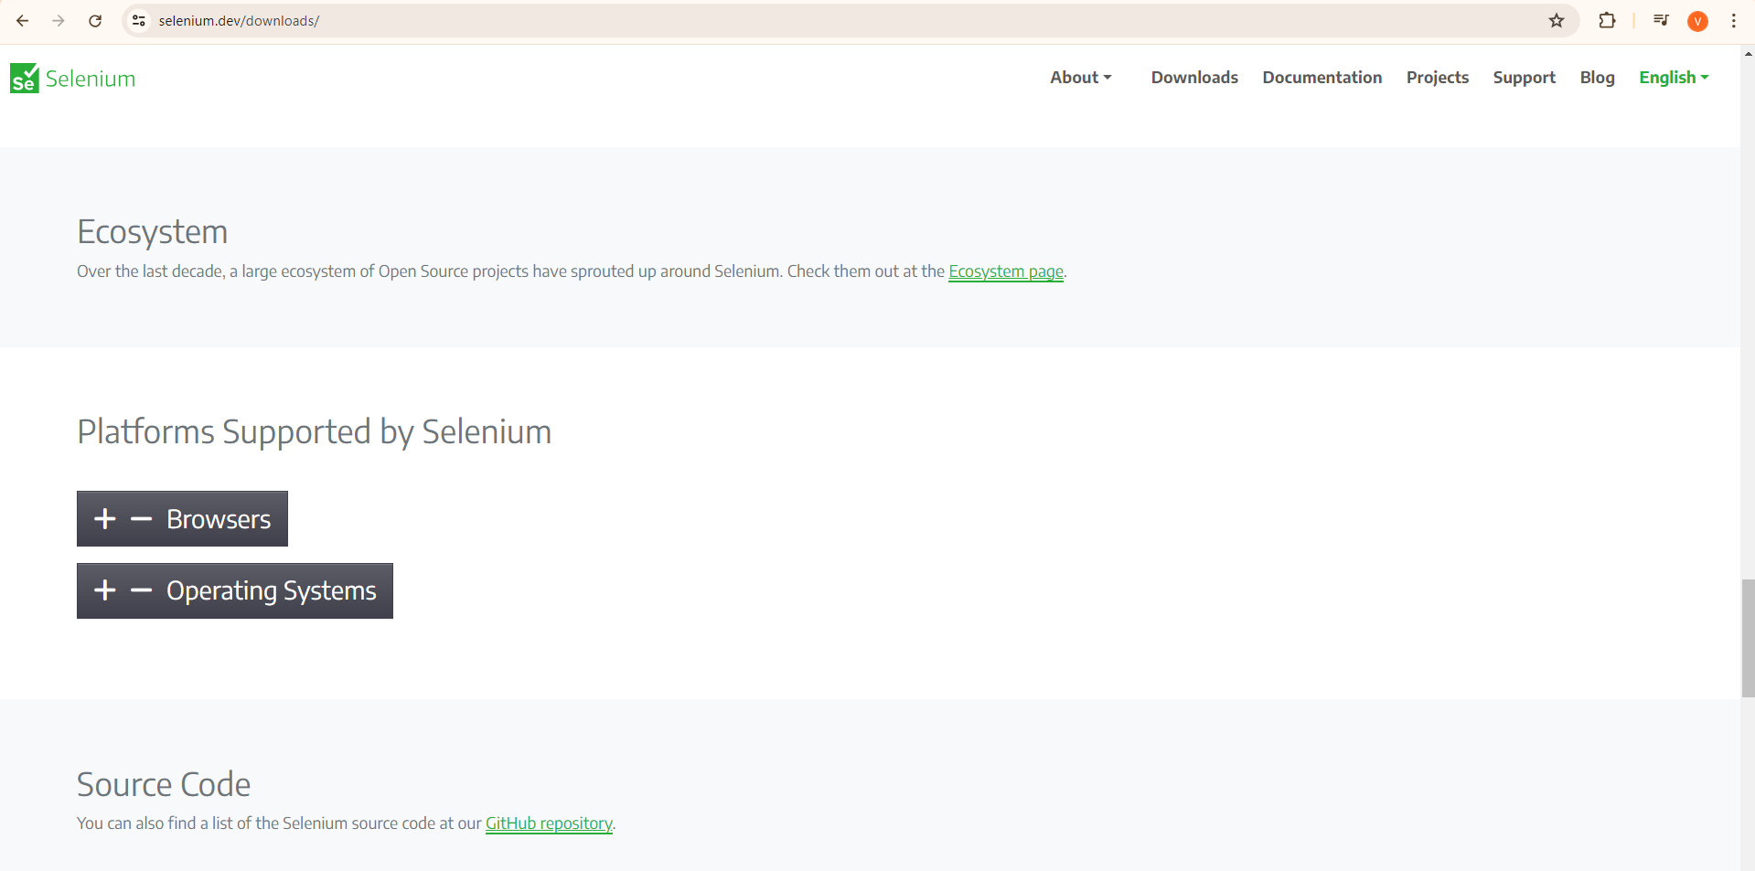

Step 4 : Click on browsers and download the browser which is compatible with your PC

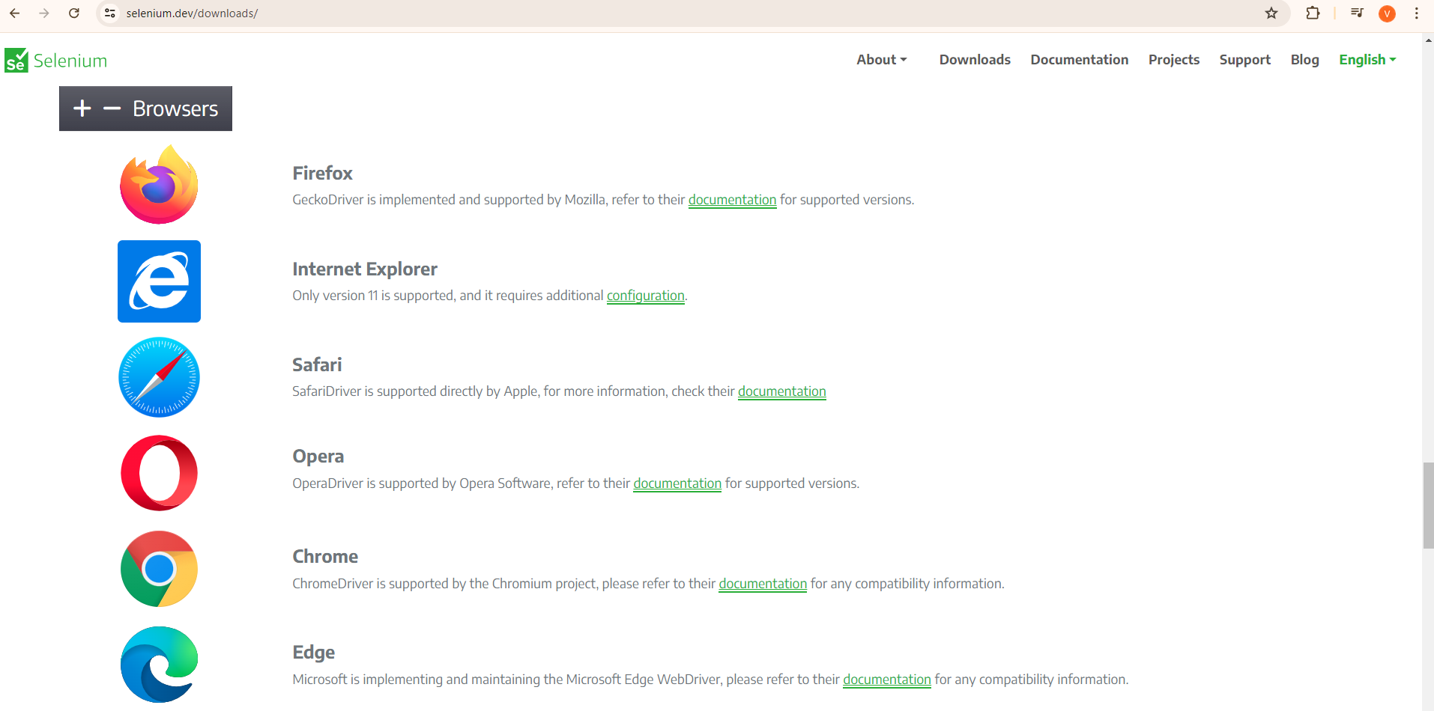

**Steps to install TestNG :**

Step 1 : Open eclipse

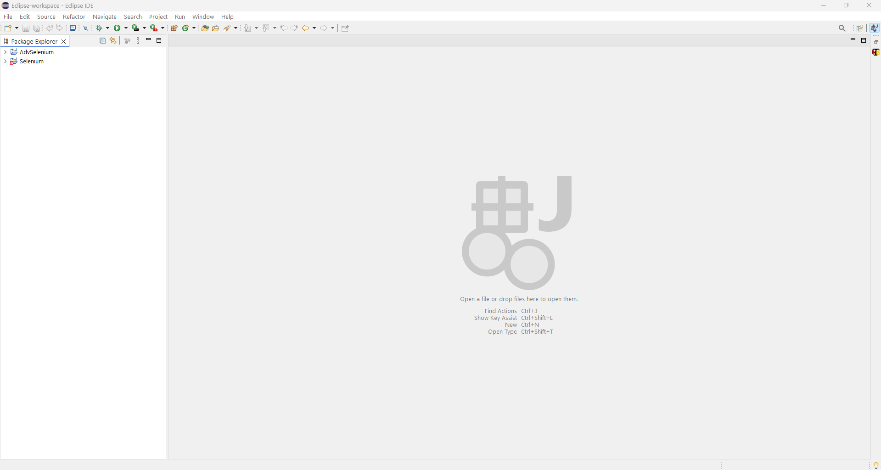

Step 2 : Click on Help >> Eclipse Marketplace

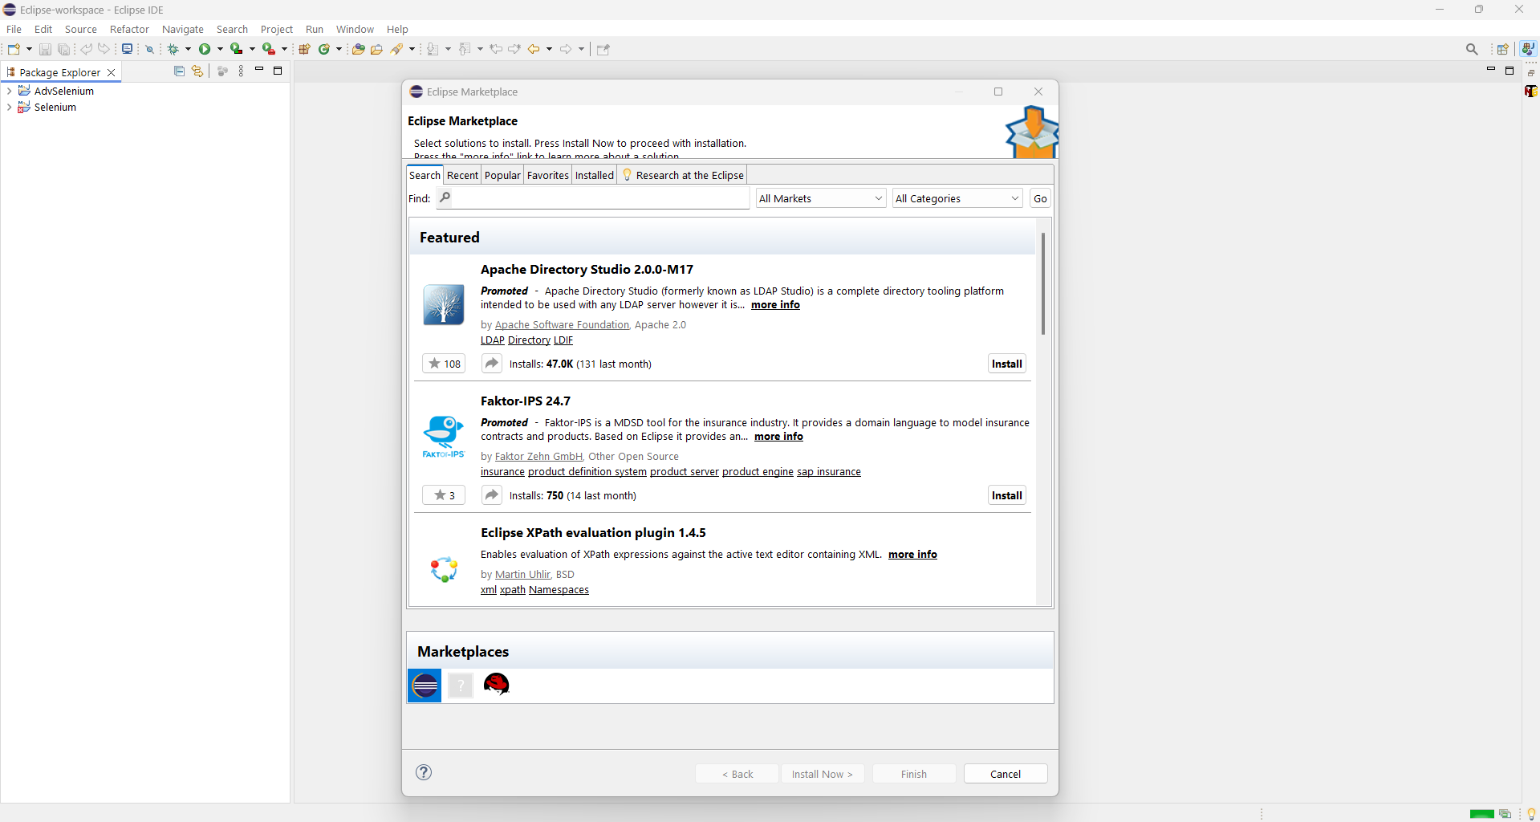

Step 3 : Search for TestNG and install TestNG for Eclipse

